**UNIT 1: OPERATING SYSTEM INTRODUCTION**

# What Operating Systems Do

An **Operating System (OS)** is a software layer that manages hardware resources and provides services for application programs and users. The OS acts as an intermediary between hardware and software. It handles a variety of functions that are essential for the smooth operation of a computer system, making it easier for users and programs to interact with the computer hardware.

**Key Functions of an Operating System:**

1. **Process Management**:
   * The OS manages processes running on the computer, including **scheduling**, **execution**, and **termination** of processes. It ensures that each process gets enough CPU time and that processes do not interfere with each other. o **Multitasking**: Allows multiple processes to run concurrently. o **Process Synchronization and Communication**: Handles coordination and communication between processes, especially in multitasking systems.
2. **Memory Management**:
   * The OS manages the computer’s **memory** (RAM). It ensures that each process has enough memory and that memory is allocated efficiently. o **Virtual Memory**: Allows the OS to use disk space as an extension of RAM, enabling larger applications to run than would be possible with only physical memory.
3. **File System Management**:
   * The OS provides a file system to store, organize, retrieve, and manage files on storage devices like hard drives and SSDs.
   * It allows operations like **creating**, **deleting**, **reading**, and **writing** files while ensuring security and integrity.
4. **Device Management**:
   * The OS controls input and output devices (I/O devices) like keyboards, mice, printers, and displays. It provides device drivers to facilitate communication between the devices and the computer.
   * It manages the queues of requests to I/O devices, ensuring that data is transferred efficiently.
5. **Security and Access Control**:
   * The OS is responsible for ensuring the security of the system by enforcing **user authentication** (through passwords, biometrics, etc.), **access control policies**, and **data protection** mechanisms. o It manages **permissions** for different users and processes, determining who can access what resources.

1. **User Interface**:
   * The OS provides an interface for users to interact with the computer, typically through a **command-line interface (CLI)** or **graphical user interface (GUI)**.
   * It translates user actions into instructions that the hardware can execute.
2. **Network Management**:
   * Many operating systems also manage network connections, allowing computers to communicate with other systems over local or wide area networks. o They handle tasks like setting up network interfaces, managing connections, and providing protocols like TCP/IP for communication.

# Computer System Organization

Computer system **organization** refers to the internal structure of a computer and how its various components interact. It outlines the **hardware configuration** of the system and how the OS manages these components to ensure the overall system works effectively.

**Key Components of Computer System Organization:** 1. **Central Processing Unit (CPU)**:

* The CPU is the "brain" of the computer, responsible for executing instructions and controlling other parts of the system. o **Control Unit (CU)**: Directs the operation of the processor by interpreting and executing instructions.
* **Arithmetic Logic Unit (ALU)**: Performs arithmetic and logical operations.
* **Registers**: Small, high-speed storage locations used to hold data and instructions that are immediately needed by the CPU.

1. **Memory**:
   * The computer's memory is divided into **primary memory** (RAM) and **secondary memory** (disk storage). o **Cache Memory**: A small, very fast type of memory used to store frequently accessed data.
   * **Main Memory (RAM)**: Holds the data and instructions currently in use.
   * **Virtual Memory**: A technique where part of the disk is used as an extension of

RAM.

1. **Input and Output Devices**:
   * These devices allow the computer to interact with the outside world. Input devices include the keyboard, mouse, and scanner, while output devices include monitors, printers, and speakers.
   * The OS handles communication between these devices and the CPU.
2. **Bus System**:
   * The bus is a set of pathways used for transferring data between components of the computer system (e.g., CPU, memory, I/O devices). o **System Bus**: Carries data, address, and control signals between CPU, memory, and other devices.

1. **Storage**:
   * **Primary storage (RAM)** is temporary and volatile, meaning it loses its contents when power is turned off.
   * **Secondary storage** (hard drives, SSDs) is non-volatile and stores data long-term. o The OS is responsible for managing both types of storage, organizing data in files, directories, and allocating space as needed.
2. **System Clock**:
   * The clock generates regular pulses that synchronize operations of the CPU and other components, controlling the timing of processes and tasks.

# Computer System Architecture

Computer system **architecture** refers to the **design** of a computer system, including the specification of its components, their interactions, and how it processes instructions. The architecture defines how the system's hardware works together to execute instructions and perform tasks. It is often divided into two broad categories: **Von Neumann Architecture** and **Harvard Architecture**.

**Key Aspects of Computer System Architecture:**

1. **Von Neumann Architecture**:
   * This is the traditional architecture used in most general-purpose computers.
   * It uses a **single memory** space for storing both instructions and data, which are fetched and processed by the CPU.
   * Key components:
     + **CPU**: Composed of an ALU, control unit, and registers.
     + **Memory**: Shared space for both instructions and data.
     + **Input/Output (I/O)**: Devices to communicate with external systems.

1. **Harvard Architecture**:
   * In this architecture, **instructions** and **data** are stored in separate memory spaces. o This separation allows for more efficient execution, as instructions can be fetched simultaneously with data, improving performance in specialized applications like digital signal processing. o Commonly used in embedded systems, microcontrollers, and signal processing applications.

1. **Pipeline Architecture**:
   * **Pipelining** is a technique used in modern CPU architectures to increase instruction throughput by overlapping the execution of multiple instructions.
   * A pipeline is divided into stages, such as instruction fetch, decode, execute, and write-back, with multiple instructions being processed in different stages simultaneously.

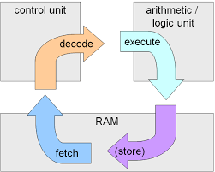

1. **RISC vs. CISC**:
   * **RISC (Reduced Instruction Set Computing)**: A CPU architecture that uses a small set of simple, highly optimized instructions, aiming for faster execution.
   * **RISC** architectures are more **pipeline-friendly(efficient)** due to their simple, uniform instructions. The instruction execution stages can be easily overlapped, which improves performance.
   * **RISC** architectures typically make **extensive use of registers** to hold data, aiming to minimize memory access. Most operations are performed between registers, and memory operations are kept separate (load and store instructions).
   * **CISC (Complex Instruction Set Computing)**: A CPU architecture that uses a larger set of more complex instructions to accomplish tasks in fewer lines of code. o **CISC** architectures can be less efficient in **pipelining** because of the variable length and more complex instructions. The complexity of CISC instructions makes it harder to predict instruction lengths and their execution time.
   * **CISC** architectures tend to rely more heavily on **memory access** in their instructions. A single instruction may directly manipulate memory, reducing the number of registers used compared to RISC.
2. **Multiprocessor Systems**:
   * Modern computer systems often use **multiple processors (CPUs)** to improve performance.
   * Multiprocessing is a method which makes a computer system to have more than one processor for enhancement of performance
   * **Symmetric Multiprocessing (SMP)**: All processors have equal access to memory and I/O devices, sharing the workload.
   * **Asymmetric Multiprocessing (AMP)**: One primary processor controls the system, while others are used for specific tasks.

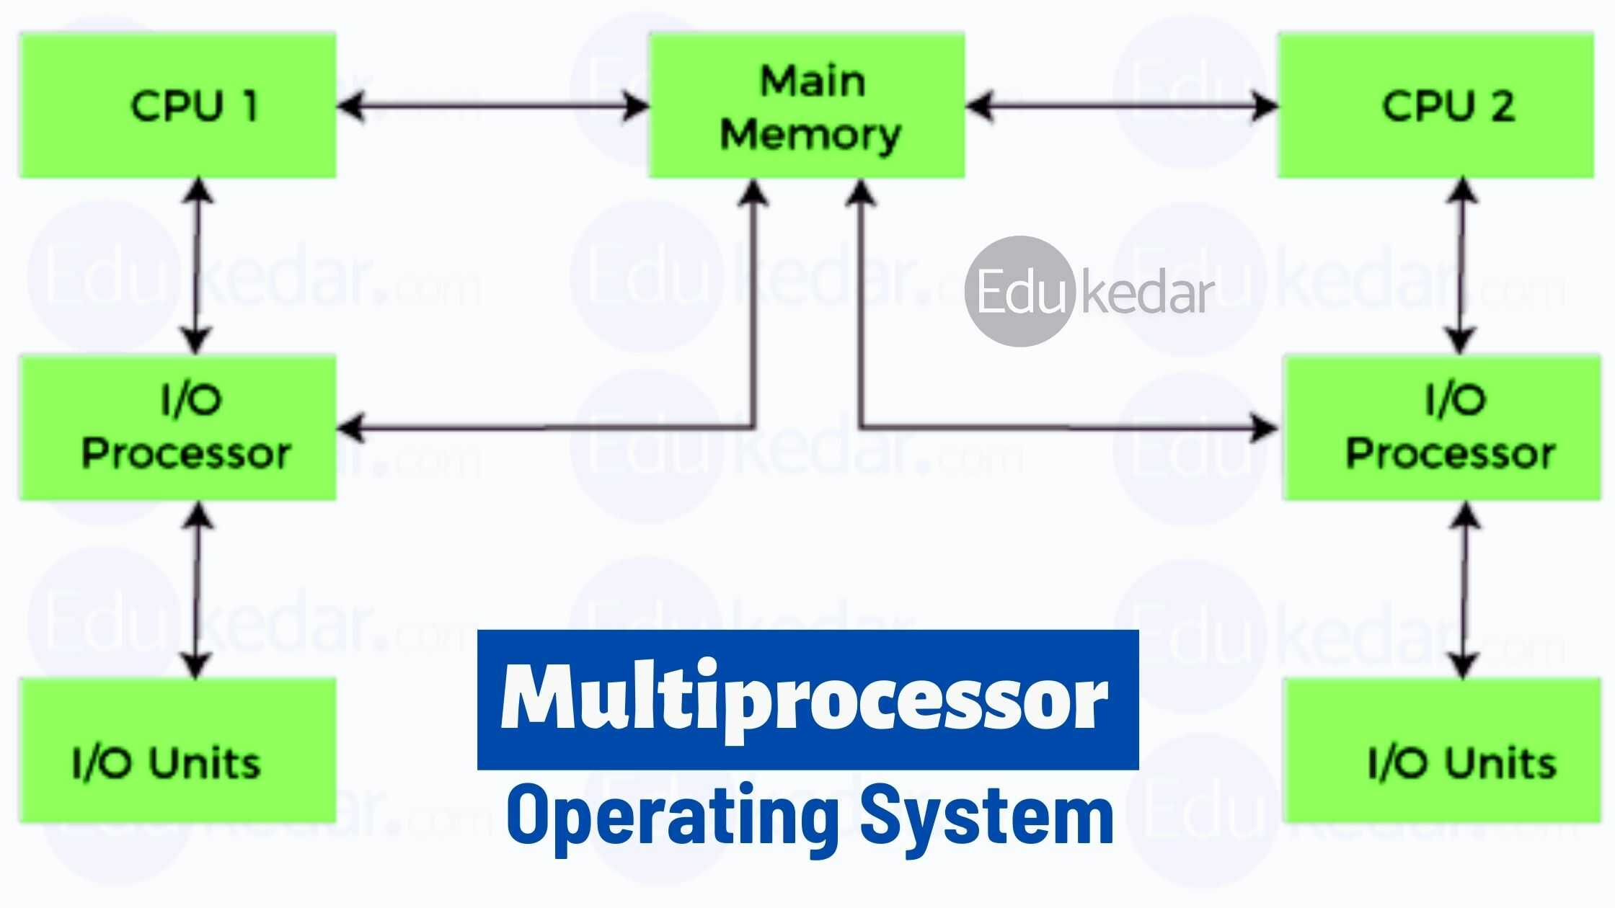

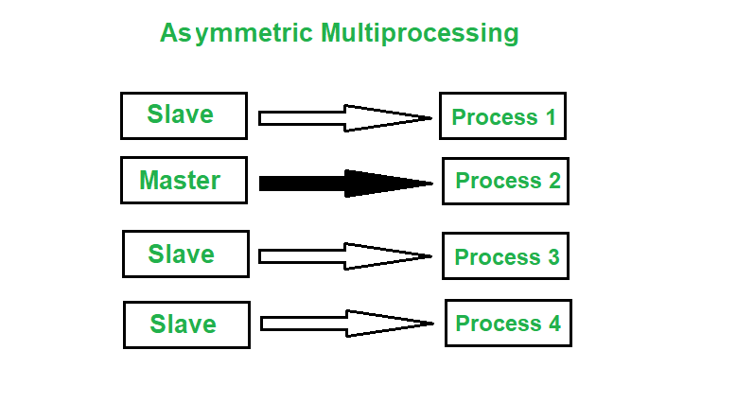 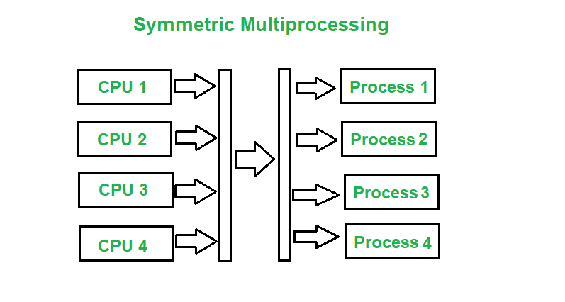

1. **Memory Hierarchy**:
   * Modern computers have a memory hierarchy designed to balance speed and cost.
   * A Memory Hierarchy is a multi-level system of computer memory, designed to balance cost, speed, and capacity

It includes:

* + - **Registers** (fastest, smallest)
    - **Cache Memory** (L1, L2, L3)
    - **Main Memory (RAM)** (larger, slower)
    - **Secondary Storage** (hard drives, SSDs) (largest, slowest)
    - 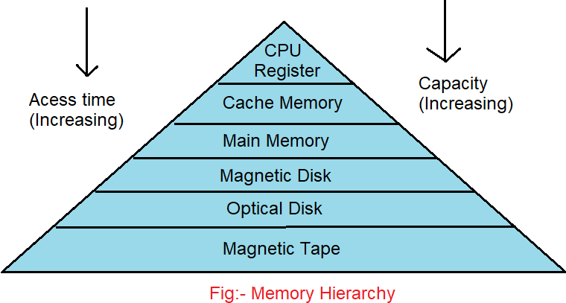

The OS manages this hierarchy by deciding where to store data to minimize access time, balancing the speed of access with the cost of different memory types.

# Summary

* **Operating Systems** manage resources like CPU, memory, files, and I/O devices, providing services to users and applications.
* **Computer System Organization** refers to the physical components of a computer, such as the CPU, memory, storage, and input/output devices, and how they are structured and connected.
* **Computer System Architecture** is the design and structure of a computer, specifying how components like the CPU, memory, and storage interact to perform tasks efficiently. It includes different models like Von Neumann, Harvard, and RISC/CISC architectures.

# Process Management

Process management refers to how an operating system (OS) handles processes, which are instances of running programs. The OS ensures the efficient execution, scheduling, and coordination of processes.

**Key Concepts in Process Management:**

* **Process Scheduling:** The OS determines which process gets access to the CPU and when. This is done using scheduling algorithms like **Round Robin**, **First-Come-First Served (FCFS)**, and **Priority Scheduling**.
* **Process States:** A process can be in various states, including **New**, **Ready**, **Running**, **Blocked**, and **Terminated**.
* **Context Switching:** When the OS switches between processes, it saves the current process's state and loads the next process’s state. This allows multitasking and multithreading.
* **Inter-Process Communication (IPC):** This includes mechanisms like **message passing**, **semaphores**, and **shared memory**, allowing processes to communicate or synchronize.

# Memory Management

Memory management involves managing the system's RAM and ensuring that each process gets the necessary amount of memory to execute while preventing interference between processes.

**Key Concepts in Memory Management:**

* **Memory Allocation:** The OS allocates memory space to processes. It can be done statically (at compile time) or dynamically (at runtime).
* **Paging and Segmentation:** **Paging** divides memory into fixed-size pages, while **segmentation** divides memory into variable-sized segments.
* **Virtual Memory:** This allows the OS to use disk storage as an extension of RAM, enabling programs to run with more memory than is physically available.
* **Memory Protection:** The OS prevents one process from accessing the memory of another process. Techniques like **base and limit registers** or **memory isolation** are used to enforce this.

# Protection and Security

Protection and security are crucial aspects of an OS, ensuring that users and processes do not interfere with one another and that data is kept secure from unauthorized access.

**Key Concepts in Protection and Security:**

* **Access Control:** The OS implements access control mechanisms such as **user authentication**, **authorization**, and **permissions** to ensure only authorized users can access certain resources.
* **Encryption:** The OS may encrypt sensitive data to protect it from unauthorized access.
* **Firewalls and Antivirus:** The OS may include features like **firewalls** to prevent unauthorized network access and **antivirus** to detect and remove malicious software.
* **Security Policies:** The OS may use security models like **Bell-LaPadula** (focused on confidentiality) or **Biba** (focused on integrity) to enforce security policies.

# Distributed Systems

Distributed systems consist of multiple interconnected computers that work together to appear as a single system to the user.

**Key Concepts in Distributed Systems:**

* **Transparency:** The OS provides the user with an illusion that the distributed system is a single machine (e.g., file access transparency, location transparency).
* **Synchronization and Communication:** The OS ensures that distributed components synchronize with each other and exchange data through protocols like **RPC (Remote Procedure Call)** or **message passing**.
* **Fault Tolerance:** The OS ensures that the system remains functional even if some components fail. Techniques include **replication** and **redundancy**.
* **Distributed File Systems (DFS):** The OS enables transparent access to files across different machines, making it seem like the files reside on a single system.

# Special Purpose Systems

Special-purpose systems are designed to perform a specific task rather than provide general purpose computing.

**Examples and Key Concepts:**

* **Embedded Systems:** These are small, specialized systems within devices like smartphones, cars, or medical equipment, often running real-time operating systems (RTOS).
* **Real-Time Operating Systems (RTOS):** RTOS systems are designed for real-time applications where the timing of operations is critical (e.g., control systems, robotics).
* **Networked Systems:** These systems are designed for handling networked services, such as web servers or DNS servers.

# Computing Environment

The computing environment refers to the hardware, software, network, and user interfaces that an OS operates in and interacts with.

**Key Concepts:**

* **Hardware Environment:** This includes the physical components like the CPU, memory, storage devices, and input/output devices.
* **Software Environment:** This includes all software running on the system, such as applications, utilities, and the OS itself.
* **User Environment:** This includes the user interface (UI), whether graphical (GUI) or command-line (CLI), that the user interacts with the OS.

# Operating System Services

Operating systems provide a variety of services to applications and users, ensuring the system runs efficiently.

**Key OS Services:**

* **File Management:** Services that allow users to create, delete, read, and write files.
* **Process Management:** Services for creating, scheduling, and terminating processes.
* **Security and Access Control:** Services to authenticate users and enforce access rights.
* **Networking:** Services for communication over networks (e.g., TCP/IP stack).
* **Device Management:** Services for controlling hardware devices, such as printers, displays, and disks.

# User Operating System Interface

The **user operating system interface** refers to the interaction between the user and the OS, typically through either a **command-line interface (CLI)** or a **graphical user interface (GUI)**.

**Key Concepts:**

* **Command-Line Interface (CLI):** Users interact with the OS by typing text-based commands.
* **Graphical User Interface (GUI):** A more user-friendly interface that allows interaction with the OS through icons, windows, and menus.
* **Shell:** The shell is a command interpreter that provides an interface for users to interact with the OS via CLI.

# System Calls

**System calls** are the primary way for applications to interact with the OS kernel. They provide the interface for the user-level programs to request services from the OS.

**Key Concepts:**

* **Types of System Calls:**
  1. **Process Control:** Create, terminate, and manage processes.
  2. **File Management:** Open, read, write, and delete files.
  3. **Device Management:** Access and control hardware devices.
  4. **Memory Management:** Allocate and free memory.
  5. **Communication:** Inter-process communication, such as message passing or semaphores.
* **Example:** A program might use a system call to request the OS to read data from a file or create a new process.

# System Program

System programs are programs that provide a platform for running applications and facilitate the management of hardware resources.

**Examples:**

* **Shell programs** that provide user interaction.
* **Compilers** that translate source code into executable programs.
* **Linkers** and **loaders** that manage the linking and loading of programs into memory.

# Operating System Design and Implementation

Designing and implementing an OS involves choosing a structure and defining how the various OS components will interact to provide services.

**Key Concepts:**

* **Modular Design:** Many modern OSes use a modular approach where components are designed as separate, reusable modules (e.g., **microkernels**).
* 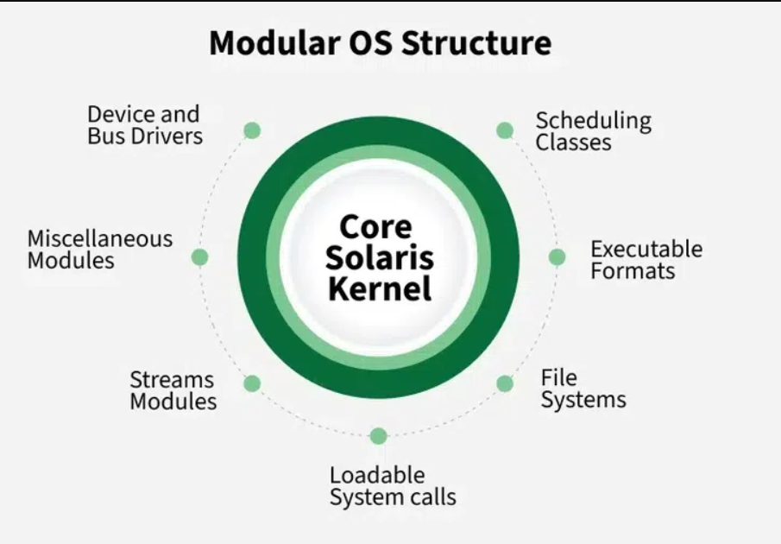
* **API and ABI:** The **Application Programming Interface (API)** provides the interface for user programs to interact with the OS, and the **Application Binary Interface (ABI)** ensures compatibility between compiled applications and the OS.

# Operating System Structure

The **structure of an OS** defines how the components of the OS interact.

**Types of OS Structures:**

* **Monolithic:** All components of the OS run in kernel space.
* **Microkernel:** Minimal core functionality in kernel mode, with other components running in user space.
* **Layered Systems:** OS is divided into layers, with each layer responsible for specific functions.
* **Modular Systems:** OS components are designed as independent modules, making it easier to extend and maintain.

# Virtual Machine

A **virtual machine (VM)** is an abstraction that allows a physical computer to run multiple OS instances. The **hypervisor** is the layer responsible for creating and managing virtual machines.

**Key Concepts:**

* **Full Virtualization:** The guest OS is unaware that it is running in a virtualized environment.
* **Paravirtualization:** The guest OS is modified to work efficiently in a virtualized environment.

# Operating System Generations

The history of operating systems is categorized into several generations based on technological advancements.

**Generations of OS:**

1. **First Generation (1940s-1950s):** Punched cards, no OS (manual control).
2. **Second Generation (1950s-1960s):** Batch processing, early batch operating systems.
3. **Third Generation (1960s-1970s):** Multiprogramming and time-sharing.
4. **Fourth Generation (1980s-Present):** Microprocessors, personal computers, graphical interfaces, and multitasking.
5. **Fifth Generation (Future):** Based on artificial intelligence and parallel processing. **15.**

**System Boot**

The **boot process** is how a computer starts up and loads the operating system.

**Key Steps in Boot Process:**

* 1. **Power on Self-Test (POST):** The hardware is tested for functionality.
  2. **Bootloader:** The OS kernel is loaded into memory. A **bootloader** (e.g., GRUB for Linux) loads the OS from the disk.
  3. **Kernel Initialization:** The OS kernel is initialized, processes are started, and the system is ready for user interaction.